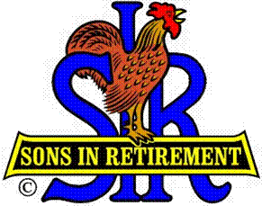

Las Trampas Branch 116

Luncheon Meeting Agenda

August 21, 2017

11:30 AM
- Call to Order – Big Sir.
- Welcome
- Pledge of Allegiance.
- Invocation: Michael Barrington
- Introduce Head Table
- Little Sir: Marty Katz
- Chaplain: Matt Arena
- Guest Speaker – David Ainsworth – Chairman SS Jeremiah O’Brian
- Introduce Guests & Visitors
- Guests:
- Visitors:
- Introduce New Members (if any)
- Big Sir Comment
- 2018 Nominations - Voting
Openings: Sam Beret (Attendance) & Pat Bermingham (Greeter)
- Sunshine Report – Matt Arena
- Storyteller – Michael Barrington

11:45 PM – Lunch
- Raffle Drawing
- SIRINC License Plates

12:15 PM
- Committee Reports

12:30 PM
Little Sir:
- Introduce Guest Speaker – David Ainsworth – SS Jeremiah O’Brian
- Ask August Birthday guys to stand / sing Happy Birthday (Paul King & Robbie)
- Sign God Bless America.

